**MANF 486: Mechatronic Systems Laboratory**

Lab #2 - Measuring Station

School of Engineering

**Introduction**

In this lab we will be exploring the capabilities of analog sensors as well as HMI control views. We will be utilizing the Festo Measuring MPS Station which is equipped with a variety of sensors and actuators along with the TIA portal software to control the station and simulate an HMI.

As we learned in previous courses, sensors can be categorized into 2 groups, analog and discrete. Analog sensors measure a continuous value such as temperature, pressure, distance, etc. Whereas discrete sensors simply measure 2 states, true or false. While discrete sensors are utilized by the MPS station being used in this lab, they will not be the main focus. Instead, we will be focusing on a single analog sensor that measures distance using a laser. In order for a sensor of this kind to be useful it must be accurate, and in order to ensure accuracy of a sensor we must calibrate it.

Sensor calibration is an incredibly important process in any setting where accuracy and precision is needed. The calibration process can vary greatly depending on the type of sensor and its application. In our case, where a high level accuracy is not needed, we can use a basic calibration process by simply measuring the output of the sensor at varying distances and plotting them against the sensor output. How we will use this data to “calibrate” the sensor will be explained in depth later in this report.

HMI’s also known as Human-Machine Interfaces are an important companion to any PLC application. They offer vast functionality but some of their main purposes are displaying important information about a station, displaying alarms and allow for operators to clear said alarms, and allow for operators to alter the operation of a station (e.g. recipes). In this lab we will be programming a simulated HMI to display information pertaining to the status of an operation, display a log of past operations, and finally allow an operator to change the recipe of the operation in real time.

**Solution Description**

Part 1: Analog Distance Sensor Calibration

In order to effectively utilize the measurement station, we must calibrate the sensor to both ensure its accuracy as well as convert its analog output into a standard unit, in this case millimeters. To perform the calibration we used calipers to measure the distance between the sensor and a surface, recording this distance along with the output of the sensor. We repeated this process incrementally through the entire range of the sensor. The data was then plotted using excel and a best fit linear line was used to estimate the relationship between the analog sensor output and the physical recorded measurement. Now that we have this equation, we can create a basic converter in our PLC program using a MATH block to accept the analog distance sensor output as an input and output the processed distance in millimeters.

Part 2: Programming Basic Functionality

We chose to code the basic functionality of the measuring station using SFC (sequential function chart) as we have the most experience with this language and it suits the functionality we are trying to code. The basic functionality we were assigned to code is outlined below:

1. When the start button is pressed the station begins its default task:

1.1. When a workpiece is detected at the start of the conveyor, the belt turns on and transports the piece to the stopper under the gripper.

1.2. The gripper deposits the workpiece onto the measuring platform.

1.3. A measurement is taken to determine if a lid is present.

1.4. The gripper returns the workpiece to the conveyor.

1.5. The stopper retracts and allows the workpiece to continue along the conveyor.

1.6. The workpiece is rejected down the slide if it did not have a lid.

1.7. The station repeats its task from step 1.1.

Programming this functionality is something we learned how to do in previous courses (e.g. MANF 386), therefore it was a fairly quick and simple process. In order to perform tasks 1.1 and 1.2, a basic chain of transitions and actions were coded, with the necessary delays between steps to ensure a smooth process. Once the workpiece is delivered to the measuring platform, a decision must be made in the PLC logic to determine whether or not a lid is present. This was easily done by finding a distance threshold using a watch table to monitor the value of the distance sensor. Once we have this threshold for determining if a lid is present, we created two branches in our main FB to carry out the two different outcomes of the functionality. The branch for workpieces with no lid will be rejected and pushed down the slide, while the branch for workpieces with a lid will allow the piece to continue to the end of the conveyor and stop.

Part 3: Trend Views

HMI’s or Human Machine Interfaces acts as the medium between a PLC and a human operator. What an HMI displays or what it can control varies greatly based on its integration and application. In this part of the lab, we programmed a simulated HMI screen to display a trend view of the distance being read by the distance sensor. This is a very simple procedure and requires little programming aside from setting the refresh rate of the trend data to 500ms and naming a new screen to display the trend. The new screen was then coded to be accessed using the F3 key from the HMI home screen.

Part 4: Historical Data

Accessing historical data from any number of inputs in a PLC system can prove to be very useful. In this case we would like to access the historical data from the distance sensor and display the history on the HMI. This was done very simply adding a historical data page to the existing HMI screen created in part 3. We can now view the history of the distance sensor as data is being collected in real time. Additionally, we would like to export this historical data for further analysis. We exported our data to an excel file where we could identify the different distance profiles for different work pieces, allowing us to apply this data in the future to identify different work pieces in real time.

Part 5: Recipes

Up to this point, our PLC program has been sent to the PLC without the ability to alter the operation of the process once it is running. In many real world scenarios, an operator needs the ability to alter a given process based on a desired result. Recipes are different outcomes of a given task based on the input of an operator.

Our first step in this lab to add some operator command, is to add a discard button on the HMI. To do this, a new DB was created and two tags were added with the following parameters:

* threshold
* discard: true = discard workpieces when the distance measurement exceeded the threshold, false = discard workpieces when the distance measurement was below the threshold

The main PLC program was then edited to incorporate these new tags and carry out the specified functionality. This was done by altering the two branches that were created in part 1. Instead of the branch path being decided directly by the input of the distance sensor, it is now decided by the status of the discard tag which is based on a given distance threshold.

A new screen was then created and elements were added to control the threshold and discard tags. This allows an operator to set a threshold as well as set the discard to true or false, determining what is discarded on the fly.

**Solution Assessment**

1. Sensor Calibration

According to the calibration graph, it can be inferred that the output of the distance sensor and the true distance being measured are intricately linked in a linear fashion. The inclination of the optimum fit line elucidates that every augmentation in the distance sensor output triggers an augmentation in the actual distance being measured, by a margin of almost 684.97 units. The y-axis interception, ascertained to be -30664, insinuates that the actual distance being measured is roughly 30,664 units when the distance sensor output is zero. The accuracy of this calibration curve can be questioned as it was drawn from a single set of measurements. Repeated trials and averaging would have increased our confidence in this result.

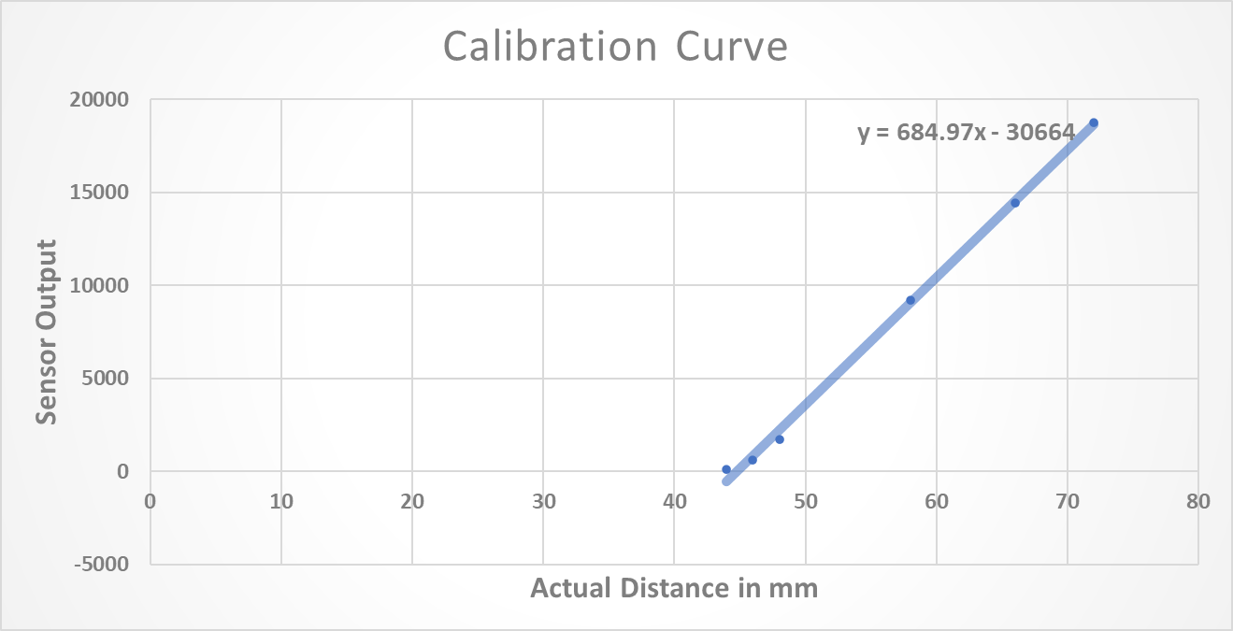

Figure 1. Calibration curve

1. Workpiece Classification

When there is no workpiece present on the measuring platform, the distance measurement equals -23mm. However, workpieces without lids also resulted in a distance of -23mm. This may be because at both these distances the sensor had reached its maximum sensing range. Placing a workpiece with a lid on the measuring platform gave a distance of 44mm. By setting the threshold at 0mm, we programmed our PLC to discard workpieces with negative distance values and only process those with positive values. This can be visualized using the distance profile in Figure 2.

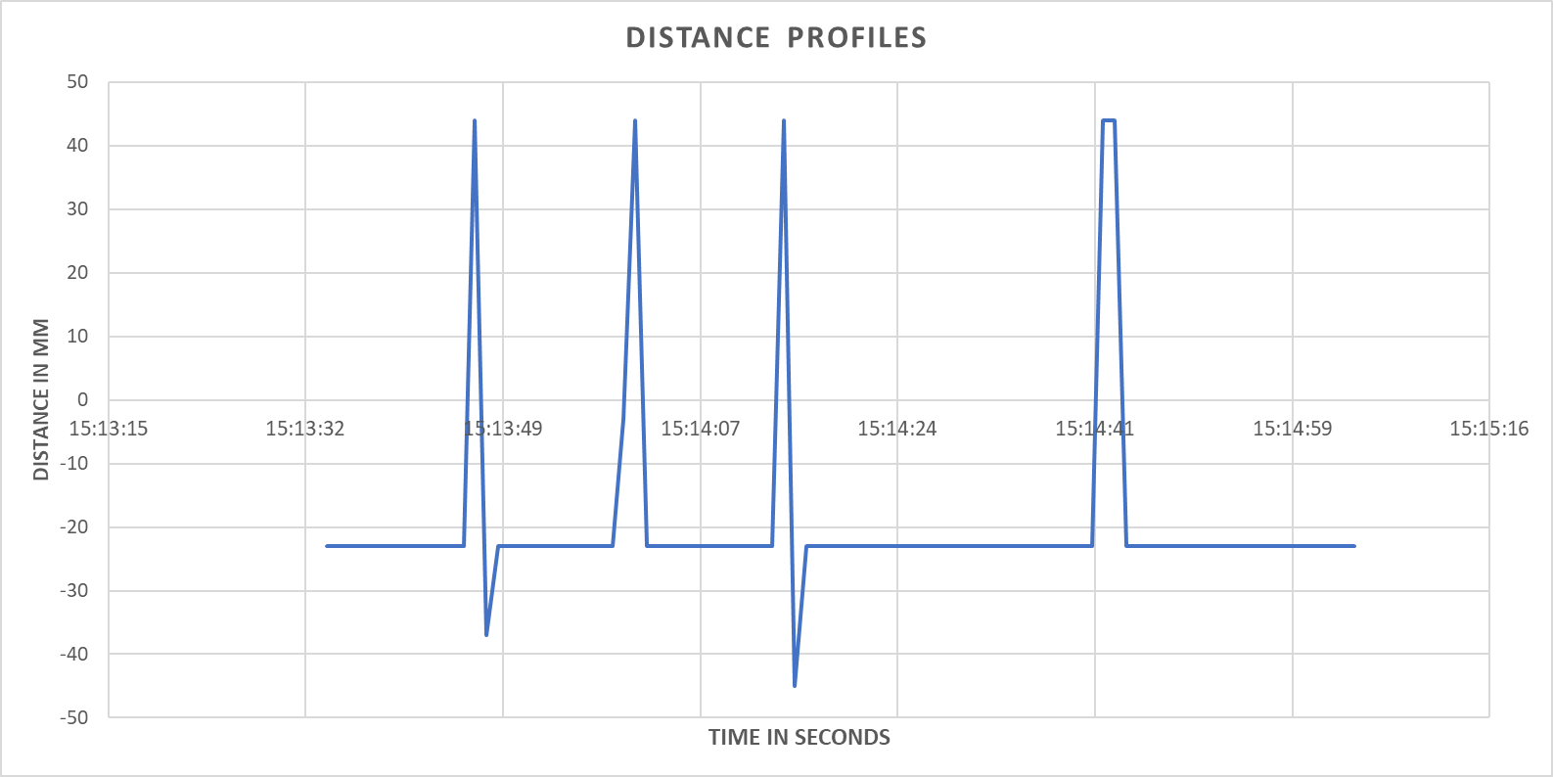

Figure 2. Distance Profiles

This was created using a historical data log and shows 4 spikes corresponding to 4 processed workpieces. From this, we know that 4 lidded workpieces were placed consecutively on the MPS station. However, we cannot tell if there were any non-lidded pieces since the distance measurement for those is the same as that observed when no workpiece has been placed on the platform.

A possible way to overcome this limitation would be to lower the height of the sensor above the platform and recalibrate it once more. This way we would have unique readings whenever a non-lidded piece is placed on the platform.

**Conclusions**

Upon completion of this lab experiment, we gained insight into the potential of analog sensors and HMI control views. To perform the lab experiment, we utilized the Festo Measuring MPS Station along with the TIA portal software. While the MPS station utilized discrete sensors, we focused on a single analog sensor that measures distance using a laser. Calibration is a crucial process to ensure the accuracy and precision of a sensor, and in our case, we implemented a basic calibration process by recording the distance between the sensor and a surface, and plotting the output against the physical measurement to estimate the relationship between the analog sensor output and the physical recorded measurement. To convert the analog sensor output into a standard unit, we created a basic converter in our PLC program using a MATH block.

In part 2 of the lab experiment, we coded the basic functionality of the measuring station using SFC. This involved implementing a sequence of actions and transitions to transport the workpiece to the stopper under the gripper, depositing the workpiece onto the measuring platform, measuring if a lid is present, and rejecting or allowing the workpiece to continue along the conveyor accordingly. To monitor the distance being read by the distance sensor, we programmed a simulated HMI screen to display a trend view, and added a historical data page to view the history of the distance sensor in real time. We also exported this historical data to an excel file for further analysis. The potential applications of HMI's and analog sensors are vast and this lab experiment provided valuable insight into their capabilities.